- Find employees with salary greater than the average salary (subquery).

select * from employees where salary > (select avg(salary) from employees);
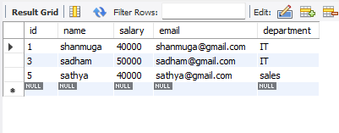
- Select products with price higher than the cheapest order.

select * from product1 where price > (select min(amount) from orders1);
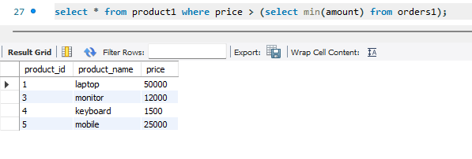
- Use a subquery inside WHERE to fetch customers with orders.

select * from customers where customer_id in (select customer_id from orders1);
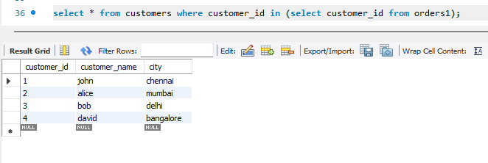
- Use a subquery inside SELECT to show order counts.

select customer_name, (select count(*)from orders1 where orders1.customer_id = customers.customer_id) as order_count from customers;
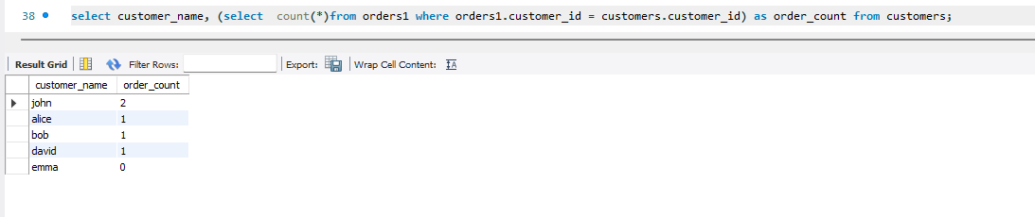
- Use a correlated subquery to find the highest salary per department.

select distinct department , salary from employees e1 where salary = (select max(salary) from employees e2 where e2.department = e1.department);
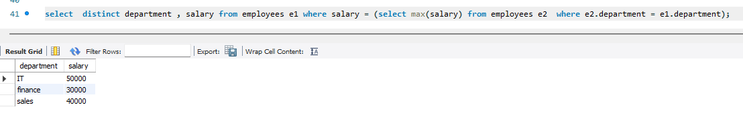
- Use a subquery to check if a product exists.

select 'product exists' as exists_or_not where exists ( select * from product1 where product_name = 'mouse');
